

**BERNARD TANG TZE WAN**

**LECTURER: Dr. LIM CHEE KAU**

**Batang Ai Optimization (Mathematical Modelling and NUMERICAL OPTIMIZATION using Matlab Quadratic Programming)**

**NUMERICAL OPTIMIZATION**

**(7011 Course Code)**

**BACKGROUND**

The Batang Ai Dam is a concrete-face rock-fill dam in Batang Ai National Park in Sarawak, Malaysia. The power station comprises four 25 MW turbines, totalling the installed capacity to 100 MW. The station is operated by Sarawak Electricity Supply Corporation. Preparations for the dam began as early as 1975, before the design was published in 1977. Construction started in 1982 with the river diversion work and the last turbine completed in 1985. The Batang Ai project, a relatively modest dam financed by the Asian Development Bank, caused the displacement of approximately 3,000 people from 26 longhouses. These people have since been accommodated in the Batang Ai Resettlement Scheme to cultivate cocoa and rubber, but the programme has not been successful.

This report is submitted in accordance to academic requirements of Course 7011 Numerical Optimization at the esteemed University of Malaya, Malaysia. I took the liberty to rekindle my interest and knowledge in MATLAB software during my past lives as a Mechanical and Manufacturing engineer (UNIMAS) as it provides in my opinion, the best path towards showing my grasp and understanding of Numerical Optimization.

Dr. Lim Chee Kau has stated clearly with regards to questions and expectations for this Group Project. The methodology I employed to achieve my optimization goal consists of 3 parts, namely Mathematical Modelling, Problem-Based Linear Programming, and Quadratic Programming. For this report, I presented with only 2 turbine models, while Batang Ai Hydroelectric Dam has 4 turbine models.

Due to resources and time limitations, many of the figures and illustrations for this report are courtesy of Matlab. I did my best to respect the trademark and copyright implication of Matlab as per clearly stated in their software user agreement. The 2 datasets used for this simulation are from the Matlab library as well. Lastly, I decided to pursue this project on my own due to misunderstandings and irreconcilable differences with my other team members.

**OBJECTIVE**

Maximise the profitability of Batang Ai Hydroelectric Dam

**INTRODUCTION**

**Part A: Mathematical Modelling**

Follow a step-by-step process for turning a problem statement into a mathematical statement. The mathematical statement is converted into a form that can be solved by Optimization Toolbox™ solvers. Figures 1 and 2 elaborate further on the processes and steps I took.

Figure 1. What is Modeling? Figure 2. Steps in Modeling

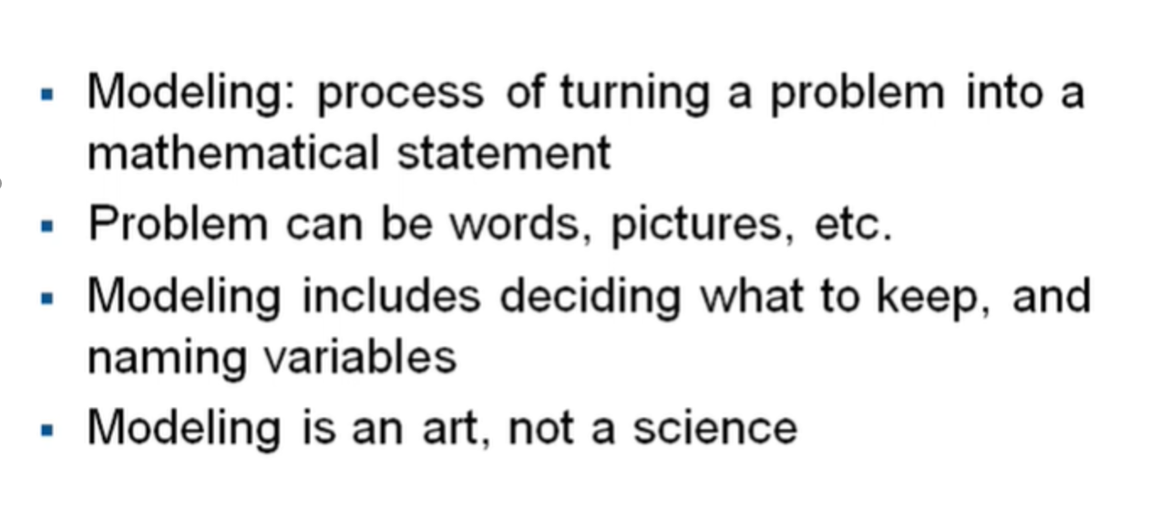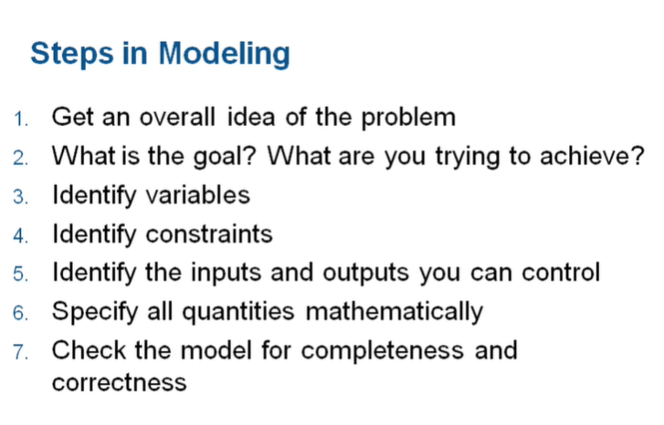

Part B: Problem-Based Linear Programming

I used the Optimization Toolbox™ to interactively define the optimization problem, variables, objectives, and constraints that represent the list of variables, constraints, and objectives in the mathematical description developed in Part A. The results of each addition to the optimization problem with the display function will then be shown before finally I can solve the optimization problem and analyze the resulting operational plan. Figure 3, 4, and 5 identifies the constraints and variables governing the Turbine 1 and 2 at Batang Ai Hydroelectric Dam.

Figure 3. Identifying Variables of Turbine 1 Figure 4. . Identifying Constraints of Turbine 1

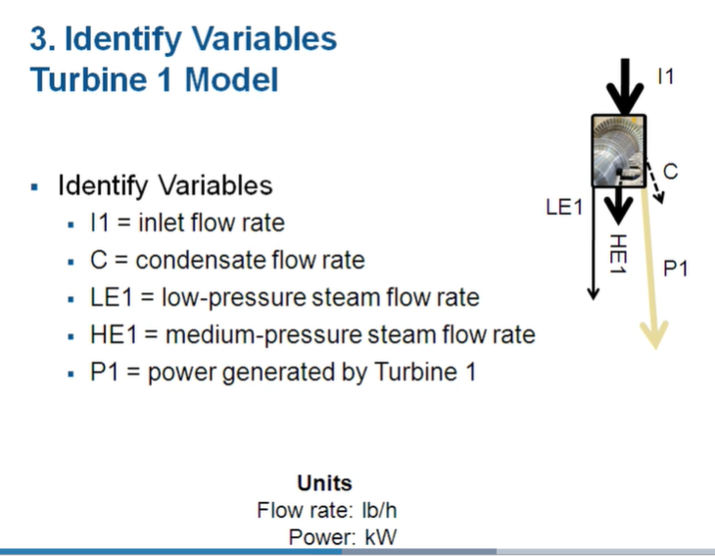 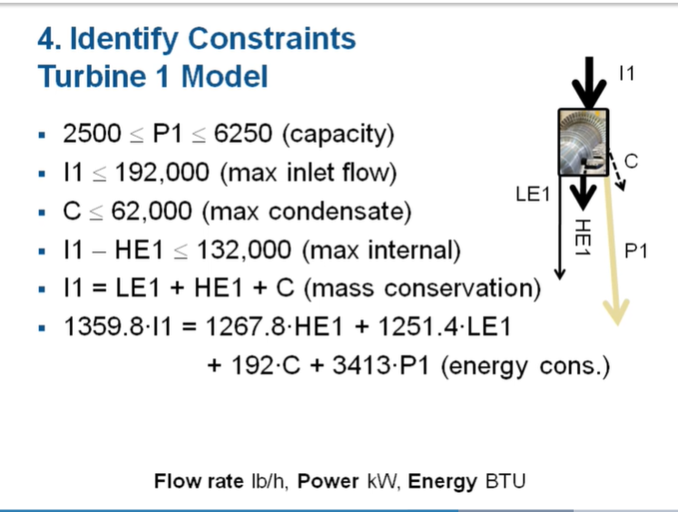

Figure 5. Identifying Variables and Constraints of Turbine 2.

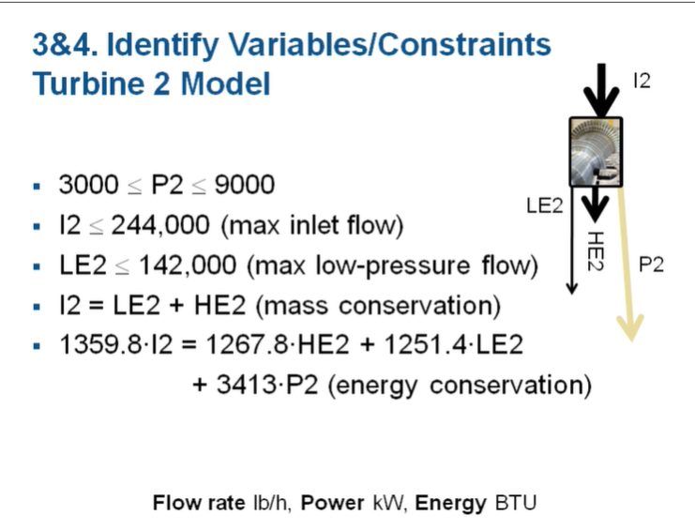

.

Figure 6 identifies the projected cost of Batang Ai Hydroelectric Dam while Figures 7 and 8 cover the projected revenue of Batang Ai Hydroelectric Dam. Figure 9 identifies the running operational cost of Batang Ai Hydroelectric Dam and finally, Figure 10 represent the Mathematical Modelling for this project.

Figure 6. Identifying projected costs of Batang Ai Hydroelectric Dam.

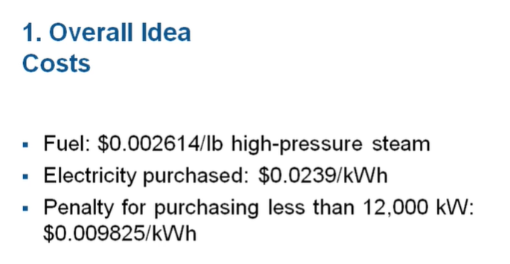

Figure 7. Identifying materials balance and demands of Batang Ai Hydroelectric Dam.

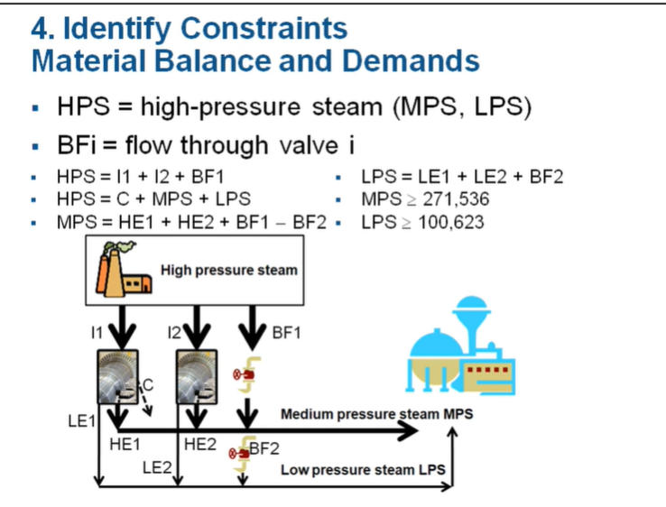

Figure 8. Identifying electrical power expressions of Batang Ai Hydroelectric Dam.

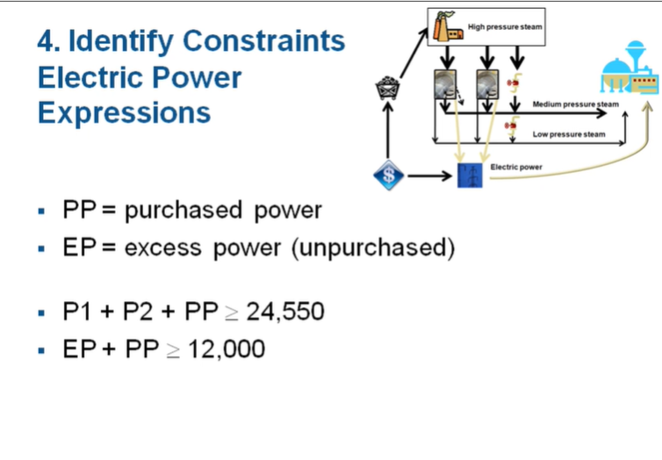

Figure 9. Identifying running operational cost of Batang Ai Hydroelectric Dam.

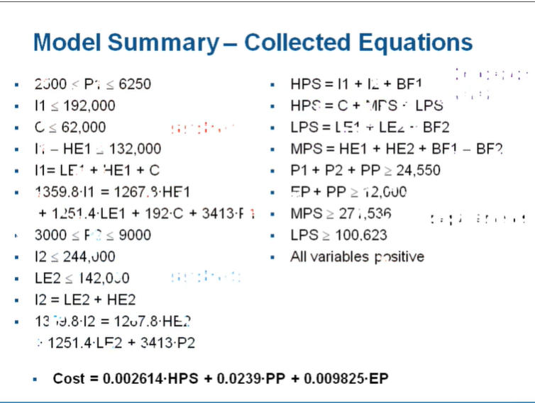

Figure 10. Mathematical Modelling

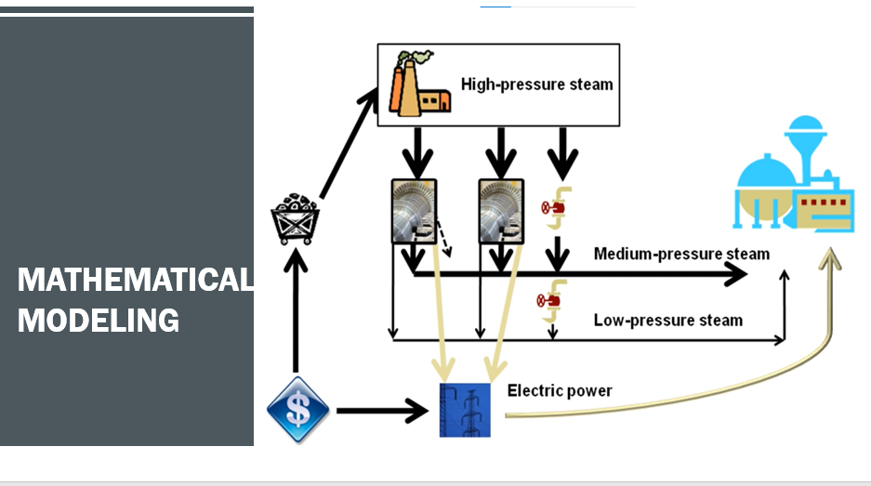

Part C: Quadratic Programming

Part A and B enable me to convert the mathematical description of the optimization problem, as developed in Part A into the arrays and matrices that the Matlab linear programming solver linprog requires. These involve the steps of a solver-based approach for which I then use to solve the optimization problem and analyze the resulting operational plan as a precautionary step.

If I were to present this report to Dr. Lim and my fellow course mates, I would have used Matlab Live editor and run it concurrently as I am presenting. However, due to timing issues, this report was submitted after the semester has ended for this course and thus, the next best thing I can do is to attach the screenshots of me running the mathematical modeling of Batang Ai Hydroelectric Dam on Matlab software here.

Figure 11. Running quadratic programming on the mathematical model of Batang Ai Hydroelectric Dam

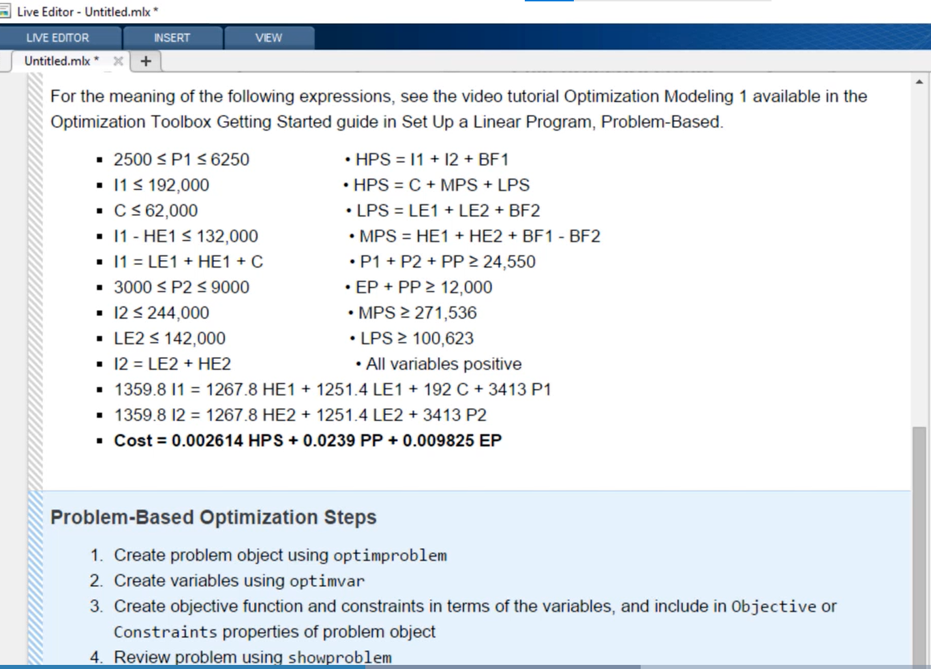

Figure 12. Setting the objective function and constraints of Batang Ai Hydroelectric Dam

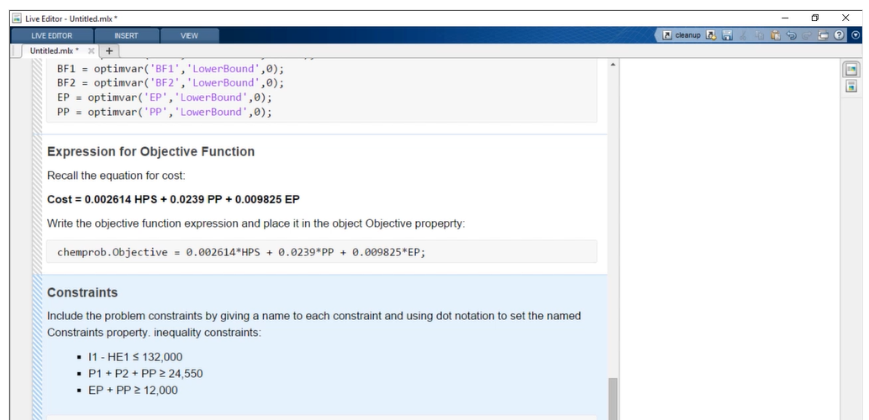

Figure 13. Optimization of Batang Ai Hydroelectric Dam

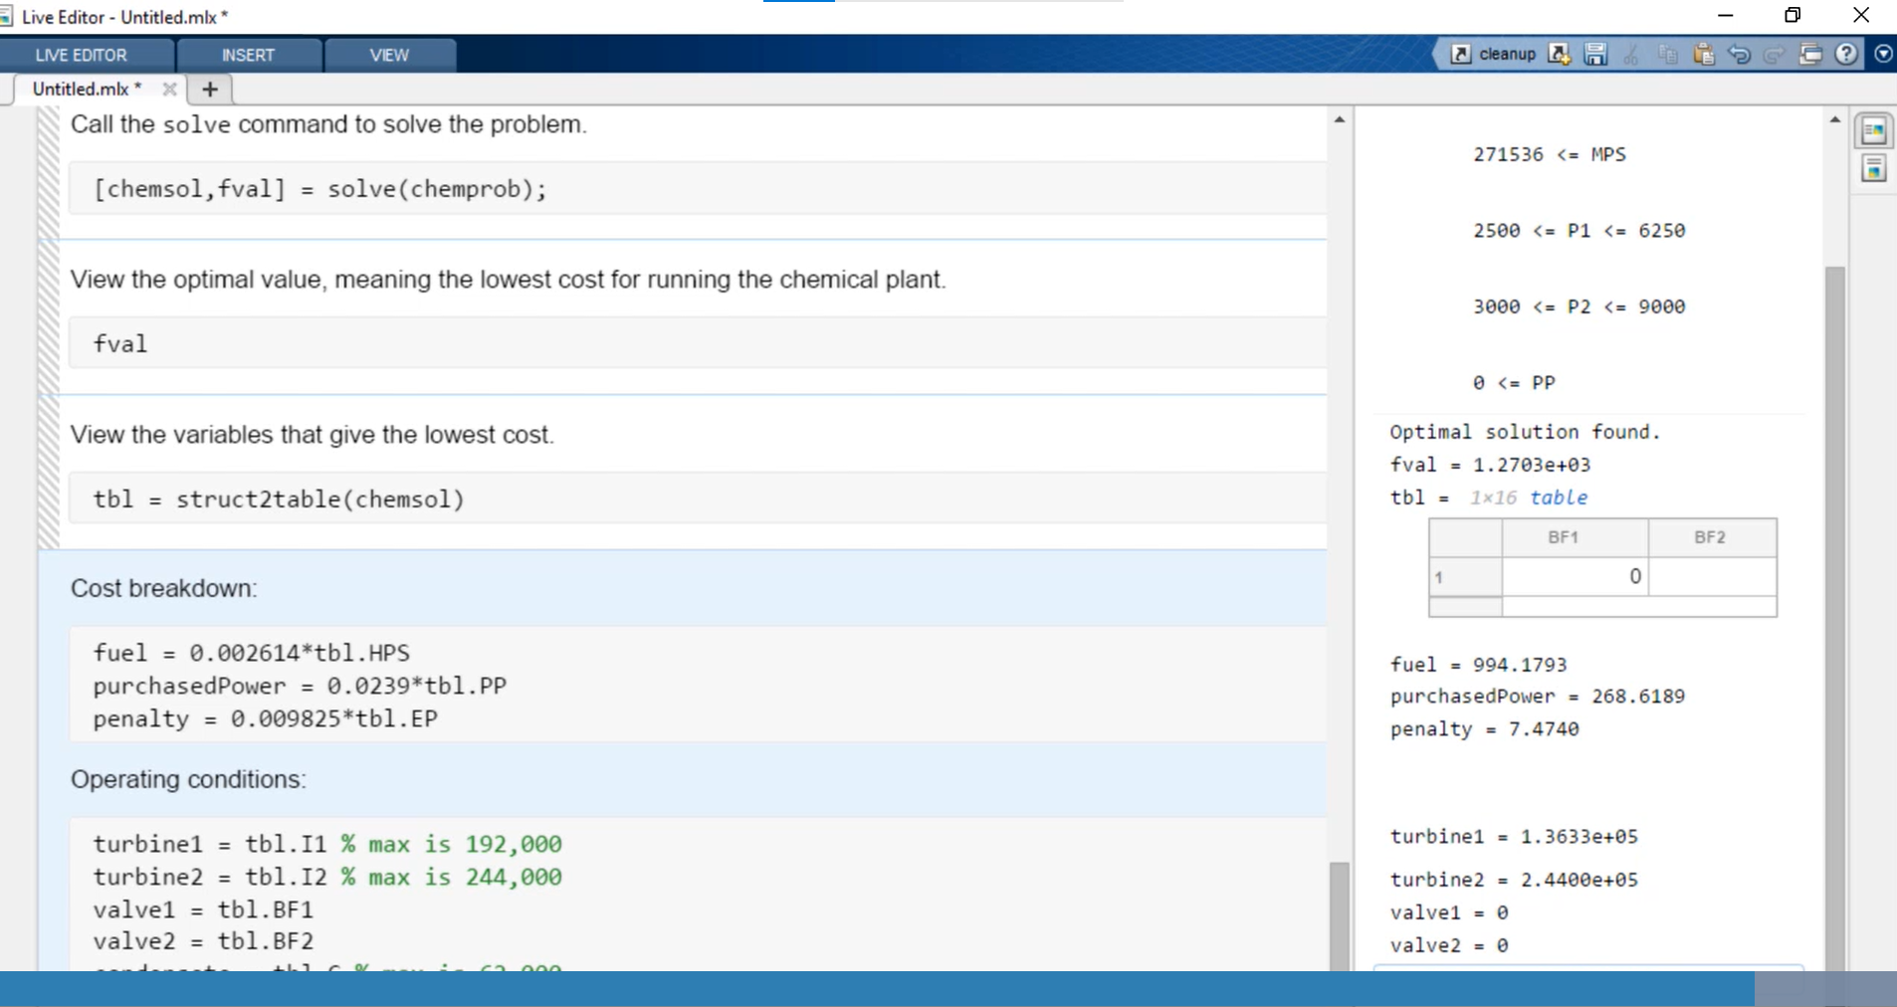

Figure 14. Matlab visualization of Batang Ai Hydroelectric Dam.

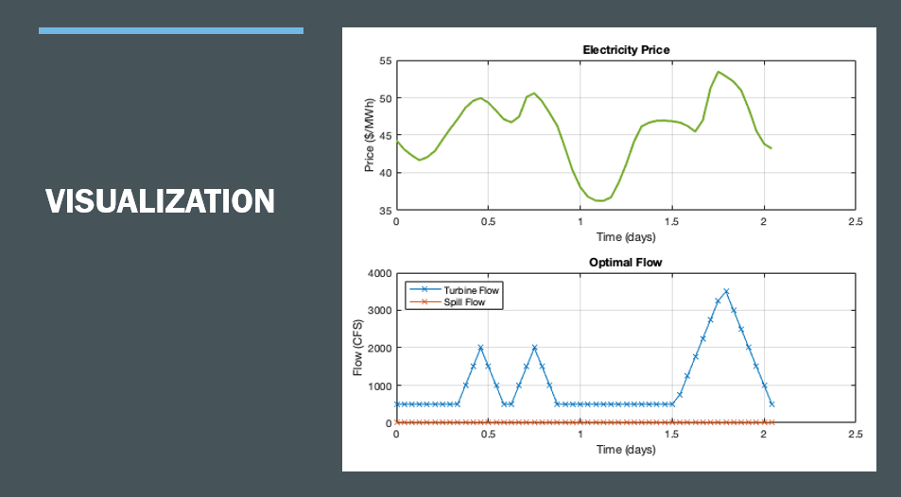

**THE END**